Kali Passive Reconaissance :
- Sudo netdiscover:
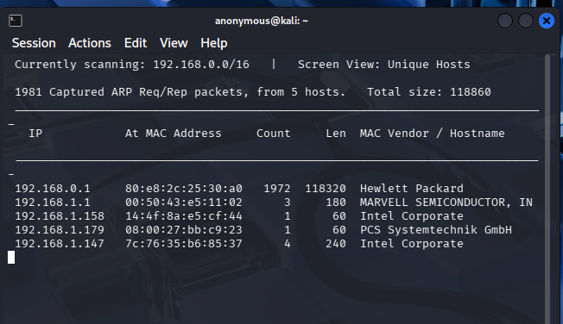
- Sudo tshark -I eth0 -f “not host [kali_ip]” :
I had an error message with this command
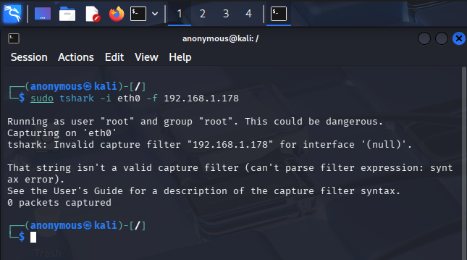

- Sudo tcpdump -ni etho -c 100:
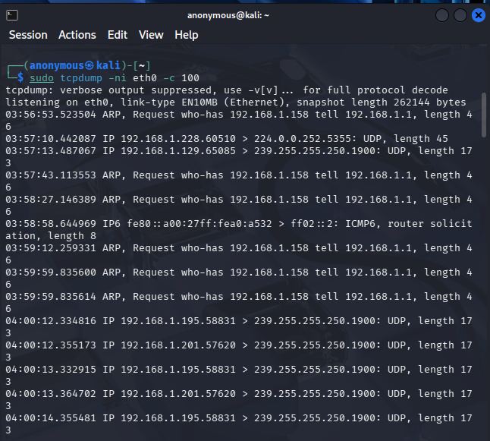
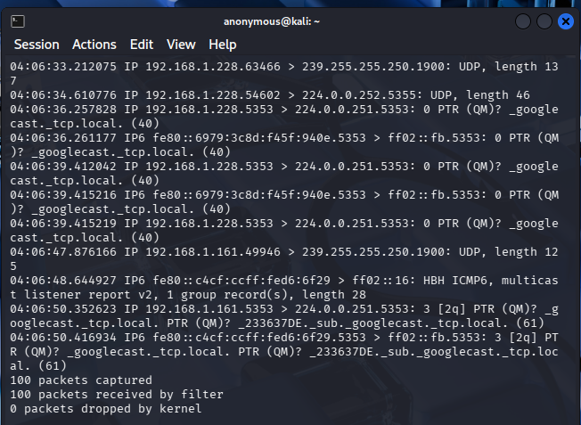
- Os Fingerprinting (Passive): u can tell which os is running by looking at the (TTL)
Sudo tcpdump -ni etho -c 100 -vv:
- Automated Evidence Collection (Bettercap)
Sudo bettercap -iface eth0:
error: command not found
